**Project Name : Monoalphabetic And Polyalphabetic Cipher**

**Phase 2 : Implementation**

**Student name : Nikhila Konda**

**Course Number : CS630-740**

**Instructor Name : Dr. Suhair Amer, Ph.D.**

**SUMMARY OF PROJECT**

In this task I am going to structure a learning device for understudies to learn math. This is the phase 2 which describes about the implementation part of the project. How the project has been implemented by using the required software tools and programming languages etc. My point is about the Monoalphabetic and Polyalphabetic Cipher.

In Cryptography, a replacement figure is a technique for scrambling by which units of plaintext are supplanted with ciphertext, as per a fixed framework; the "units" might be single letters (the most widely recognized), sets of letters, triplets of letters, blends of the abovementioned, etc. The recipient interprets the content by playing out the opposite replacement. Replacement figures can be contrasted and transposition figures. In a transposition figure, the units of the plaintext are modified in an alternate and as a rule very mind-boggling request, yet the units themselves are left unaltered. On the other hand, in a replacement figure, the units of the plaintext are held in a similar grouping in the ciphertext, yet the units themselves are adjusted. There are various sorts of replacement figure. On the off chance that the figure works on single letters, it is named a basic replacement figure; a figure that works on bigger gatherings of letters is named polygraphic. A monoalphabetic figure utilizes fixed replacement over the whole message, while a polyalphabetic figure utilizes various replacements at various situations in the message, where a unit from the plaintext is mapped to one of a few prospects in the ciphertext and the other way around. Monoalphabetic figure is a replacement figure in which for a given key, the figure letters in order for each plain letters in order is fixed all through the encryption procedure. For instance, if 'An' is encoded as 'D', for any number of event in that plaintext, 'A' will consistently get scrambled to 'D'. A polyalphabetic figure is any figure dependent on replacement, utilizing various replacement letters in order. The vigenere figure is most likely the most popular case of a polyalphabetic figure, however it is a disentangled unique case. The Enigma machine is increasingly mind boggling yet is still in a general sense a polyalphabetic replacement figure. Polyalphabetic figures are a lot more grounded. There are a wide range of types, and the quality shifts impressively. The sign is in 'poly', which means many. The most popular is the Vigenere framework (however he didn't design it) which utilizes 26 letter sets and a watchword to advise which letter to set to use for each letter to be encoded. You can undoubtedly apply a dynamic key (where keys are utilized all together in a steady progression, the most straightforward just advances the letters of the key by one spot at every redundancy) or an auto key (where the message itself figures out which letters in order are to be utilized for parts of the message after the underlying key).

By utilizing this idea depiction, I will build up a Gaming Platform to learn it in a simplicity way. This Gaming idea is helpful for any degree of understudies to become familiar with the subject. So here I am utilizing Scratch Programming Language to build up this Gaming device.

**IDEA FOR THE PROJECT**

The reason for this undertaking is to learn about figures idea in cryptography which is Monoalphabetic Cipher and Polyalphabetic Cipher and to build up a Learning Game for understudies. The fundamental moto of this task is to comprehend the ideas in a basic and simple manner along these lines, that everybody learn in little range of time. What is more, it will stay in their cerebrum for the long time. This task is useful essentially for the understudies who concentrate High school and in college to the under alumni. Learning with the assistance of gaming instrument is certifiably not an impractical notion and it likewise upgrades the innovativeness abilities in understudies. It is simple approach to learn and recollect the ideas in the minds of understudies and perform well in tests also. By utilizing this Monoalphabetic and polyalphabetic figures idea we can program by utilizing a scratch programming. Programming just implies the specialty of creating rules (computations) to train a PC.

Scratch is a visual programming language that gives an ideal learning condition to doing this. At first made by America's Massachusetts Institute of Technology, Scratch is a fundamental, visual programming language. Concealing coded squares of code basically snap together in explicit habits like a jigsaw, shedding the making botches that will as a rule happen when people utilize content-based programming lingos. Various media rich tasks can be made using Scratch, including games, exercises and clever stories. Scratch is likely the most extensively used programming for educating programming to Key Stage 2 and Key Stage 3. The Scratch interface is partitioned into two segments: the undertaking running condition and the task improvement. In the upper right of Scratch is the stage appeared at the highest point of the picture on the right. The stage is the place a Scratch venture is truly run, so when one plays a game, the Stage is the window wherein it is run. Naturally, the Scratch Cat is on the stage. The Scratch Cat is just one of numerous Sprites, or characters, catches, and so on in a task. Characters are customized to perform what a Scratcher wants them to do. The adaptability of Scratch permits the maker to be creative and really make the ideal task. That is when programming comes into place, as it "causes activities what they should". There are no open issues for playing out this undertaking utilizing the Scratch Programming. Issues with this learning instrument are less on the grounds that it depends on Block based programming language and it is anything but difficult to learn and code the venture. In the event that at all there emerges a few issues it is anything but difficult to fix them inside no time. Furthermore, the availability is helpful for any gathering of kids for making ventures. We can make different number of assignments relying on our ease of use. The trouble level of the assignment relies fair and square of understudies learning the points. While doing the undertaking in this Scratch we can change over them into some other programming language relying on our motivation of utilizing it. There is not bit of hazard engaged with this task creation and if emerges with little issue check be fixed in whenever. What is more, it is open source venture we can download free and get an entrance in a matter of seconds. What is more, can without much of a stretch build up a venture contingent on the trouble level of kids. Cryptography has for a long while been essential to understanding get-together and law prerequisite associations. Riddle trades may be criminal or even treasonous.

**PROGRAMMING LANGUAGES USED AND SOFTWARE**

Scratch is a square based visual programming language and site concentrated on basically at youths. Customers of the site can make online endeavors using a square like interface. The organization is made by the MIT Media Lab, has been changed over into 70+ vernaculars, and is used in numerous bits of the world. Scratch is not just a not too bad preface to programming; it is a real programming language in its own right. Scratch has the significant highlights of many programming dialects, similar to circles (rehash squares) and conditionals (in the event that squares). In Scratch, improvement is noteworthy for greater endeavors since Scratch is a deciphered language. Capable programming similarly allows you to have continuously content or a smaller archive size in a Scratch adventure, considering the way that the substance would consume less room, letting you make more use out of 50 MB. Scratch is secure, and customarily these people are quickly uncovered and disallowed. Basically, do not give out near and dear information and report any individual who is referencing singular information or regardless creation you ungainly and you should be fine. It justifies referencing, in any case, that you will find the discontinuous adult. Scratch has the huge features of many programming vernaculars, like circles and conditionals . With these features, Scratchers can make counts, or rules to complete unequivocal endeavors. PC analysts would state Scratch is a Turing-complete programming language, which suggests it can play out all the key limits that make up counts. In the wake of working with Scratch for quite a while, various Scratchers find that they have to continue using Scratch even as they use other programming lingos. Scratch is fine for demonstrating little children programming thoughts. I for the most part propose starting with a fair instructing language. A nice preparing language is outstandingly clear and easy to learn. It is freed from the cruft that you find in tongues like Java, Python, JavaScript and C.

Scratch is an easy to-use programming stage with the likelihood to make staggering instinctive stories, games, movies, and presentations. Scratch is a program that licenses youngsters to make their own natural stories, exercises, and games. Scratch is sans fun, and easy to use with uncommon informative worth. It is an unprecedented technique to make sense of how to code in a natural way. The social event released Scratch 3.0 as of late. Scratch programming language has a huge amount of fun, cheerful play region with a great deal of documentation. With each adjustment of Scratch, customers gain understanding and get content with controlling their virtual condition. The instinctive programming style is an astounding, low-pressure preamble to building programs. Learning Scratch incorporates controlling code impedes inside the play zone. The generous online system helps and documentation with the objective that scratch customers have a great deal of advantages. Regardless, courses expected to help you with exploiting this programming condition could be a compelling technique to break into it. You can get into Scratch in solitude viably, anyway a portion of the time having a tiny bit at a time headings to building help kick off your learning. These programming thoughts could prepare for logically basic assignments not far-removed with other programming lingos, so starting is your underlying advance. Harvey Mudd offers a course in Scratch Programming Basics in association with edX.org's informational stage. You will get acquainted with the nuts and bolts to kick you off, so you contribute less vitality overwhelmed and extra time building. In the event that you are a teacher, Delft's course unequivocally addresses the aptitudes educators need to amass applications in Scratch. If your inside is allowing your children to explore, Delft's course, Scratch Programming for Kids (8+) is proposed to kick kids off in the Scratch play territory. Adolescents will require coding capacities for occupations later on, so starting your children out in grade school could be a brilliant technique to collect those aptitudes early. stories, games, craftsmanship, entertainments, and that is only the start, using square based programming. Scratch moreover has its own paint publication administrator and sound editor worked in.

Scratch is a slide-and-drop programming language for adolescents that grants them to explore and attempt various things with the thoughts of PC programming by using the fundamental graphical interface of "obstructs" that are gathered to make essential codes. Thusly, exercises like Scratch, that were made in an altruistic and distinctive way are a bewildering course for our youngsters to start making huge aptitudes, for instance, computational thinking, algorithmic basis, basic reasoning and innovativeness. The points of interest do not stop there, there is considerably more to incorporate. By being a bit of a system of makers and creators, our youngsters will have the alternative to get the total of the analysis they need to invigorate their new developments, to check out others who may have stood up to relative issues already and to lock in on another critical limit with respect to the 21st Century. You would be shocked to make sense of the way that it is so normal to program by using Scratch's squares. With a simple to utilize interface, and with engaging tones, Scratch's originators made the ideal stage to begin the path toward making sense of how to code. By then, heading off to a programming language like Java, C++, or even Python will be a way continuously normal method for our dear little understudies. A lot of exercises that convince featured have all the earmarks of being adventures that are dynamically open to increasingly energetic adolescents, rather than adventures that display the grouping of things that can be made using Scratch's redoing. Rather than considering Scratch a "children's altering language", it should be progressed as a visual programming language basic for juveniles to use that is open and sensible for youths too. It would be helpful for Scratch to make more notification how these endeavors are redone, similarly as show cases of progressively complex exercises to speak to what customers can make once they have learnt more aptitudes in programming. This is more substantial for games than various types of assignments, yet habitually astoundingly clear games get included, and complex games consistently are not. Seeing as the primary page is the primary concern people see, it does not do a great deal to show the variety of endeavors that can be made. Continuously perplexing exercises should be incorporated additionally - you cannot expect they will get notable in solitude.

**PICTURES OF INTERFACES**

Interface of the website which I choose to develop my project of performing ciphers concept for students to learn in easy way.

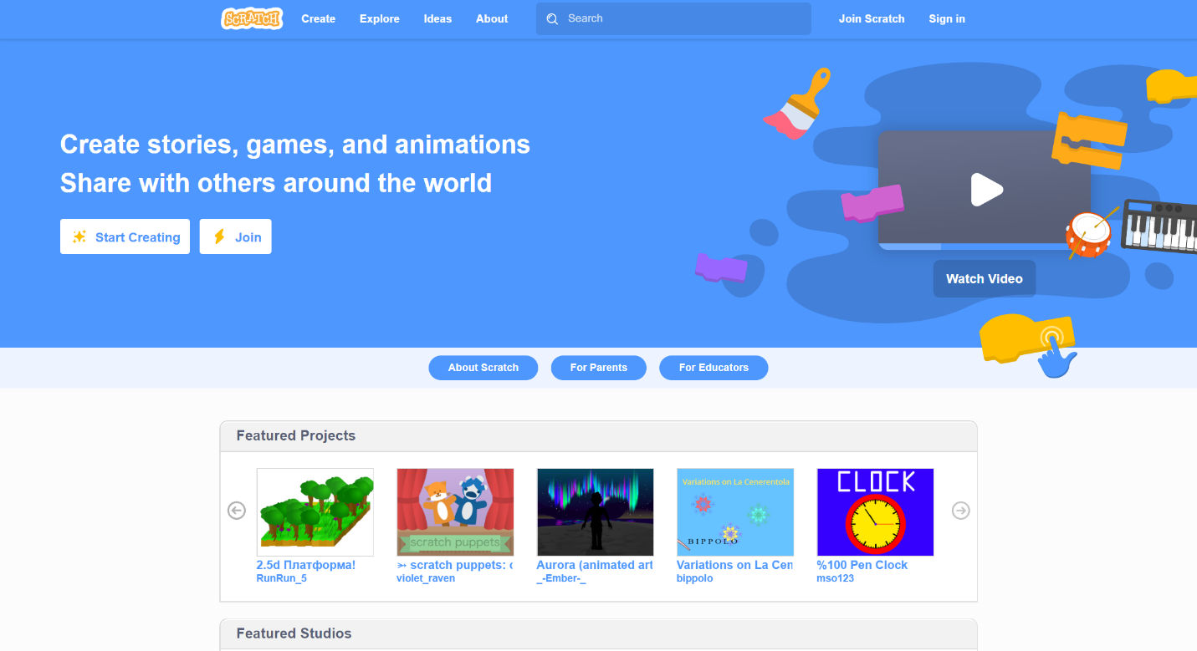

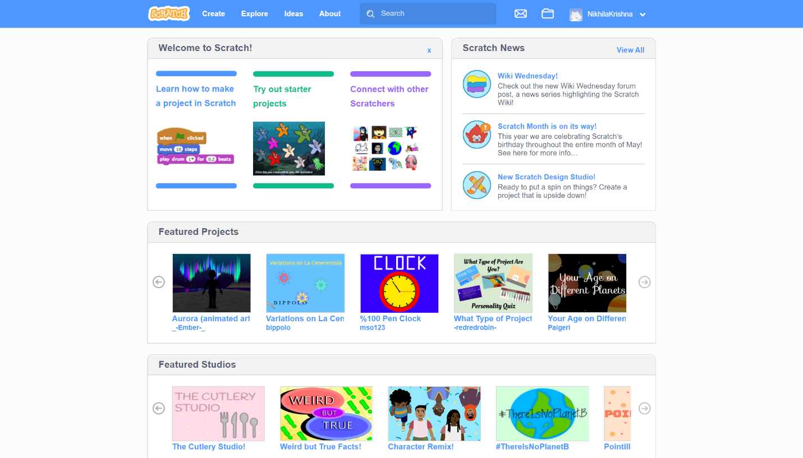

**These are the code blocks which helps us to develop the block code for the project. The above is the Motion block which controls the sprites movement.**

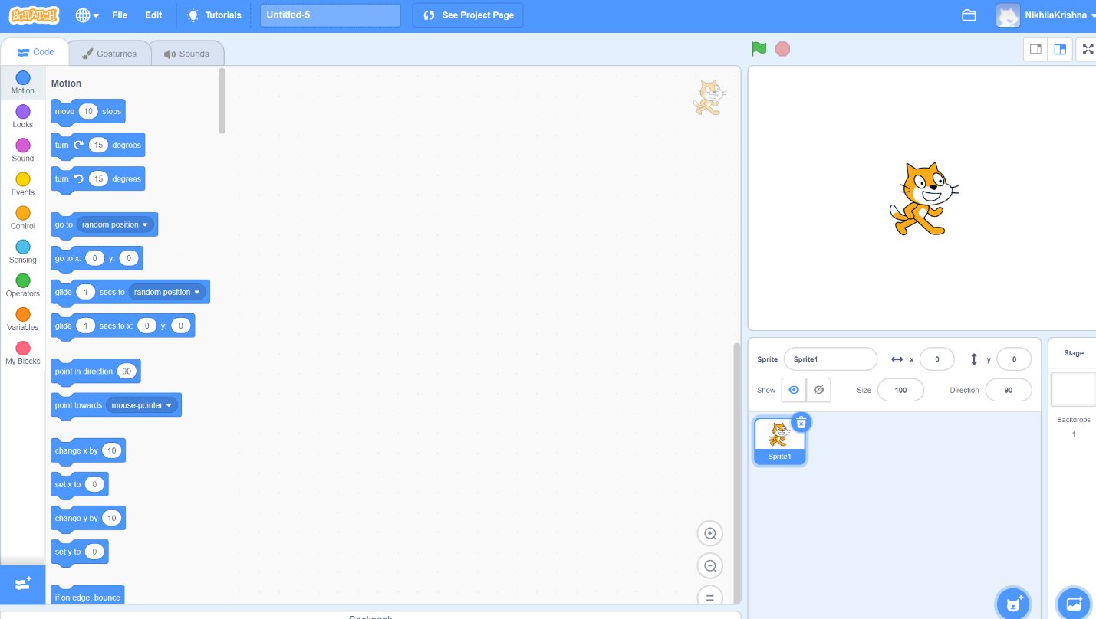

**Looks block control how a sprite looks.**

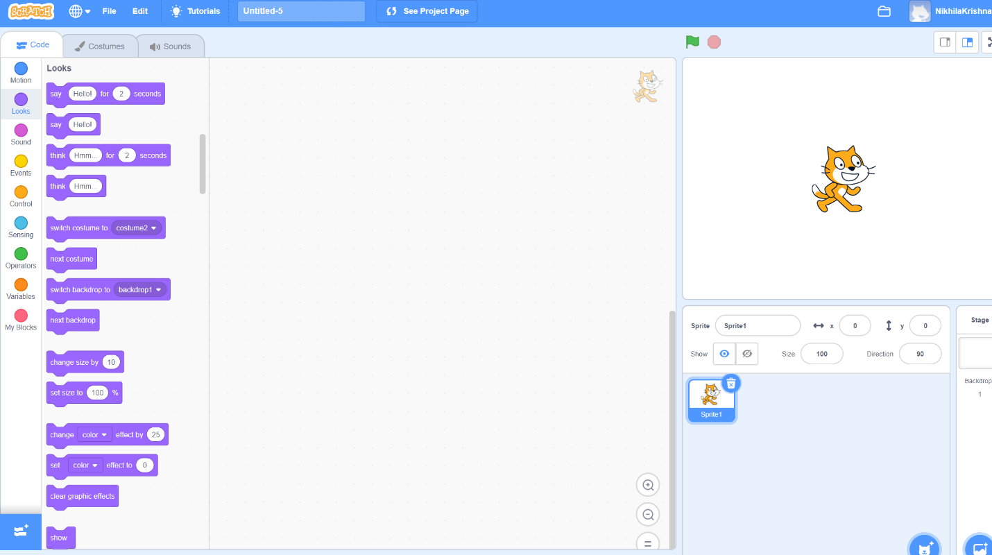

**Sound blocks are the blocks which controls the sound.**

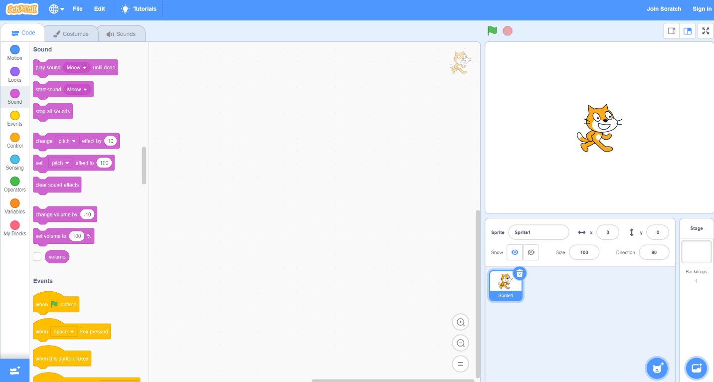

**Event blocks are the blocks that control Events and the triggering of scripts.**

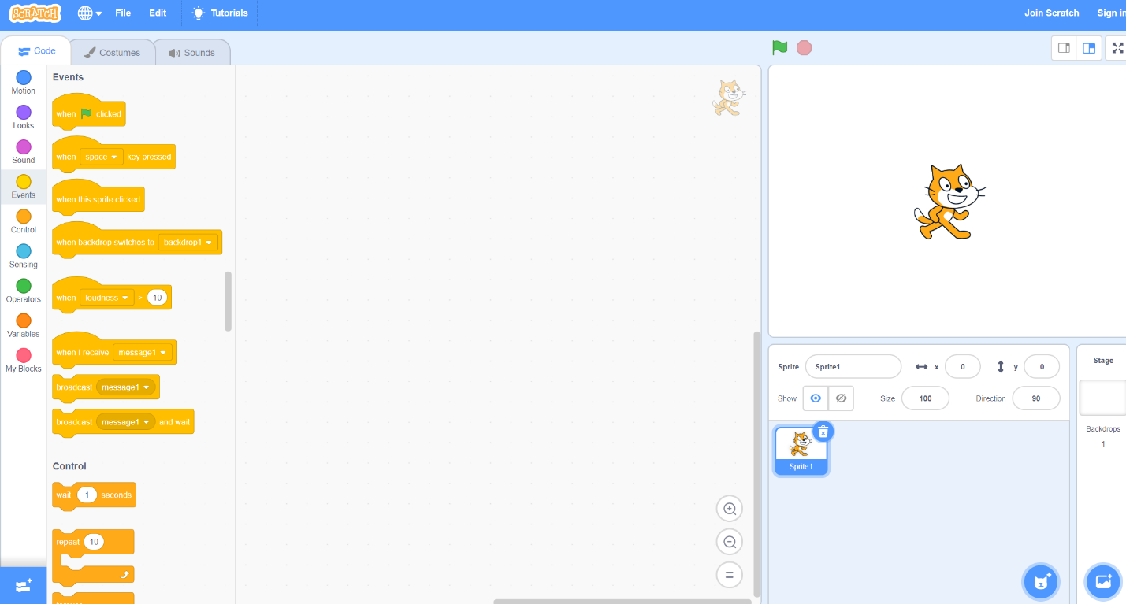

**Control blocks are the blocks that control scripts.**

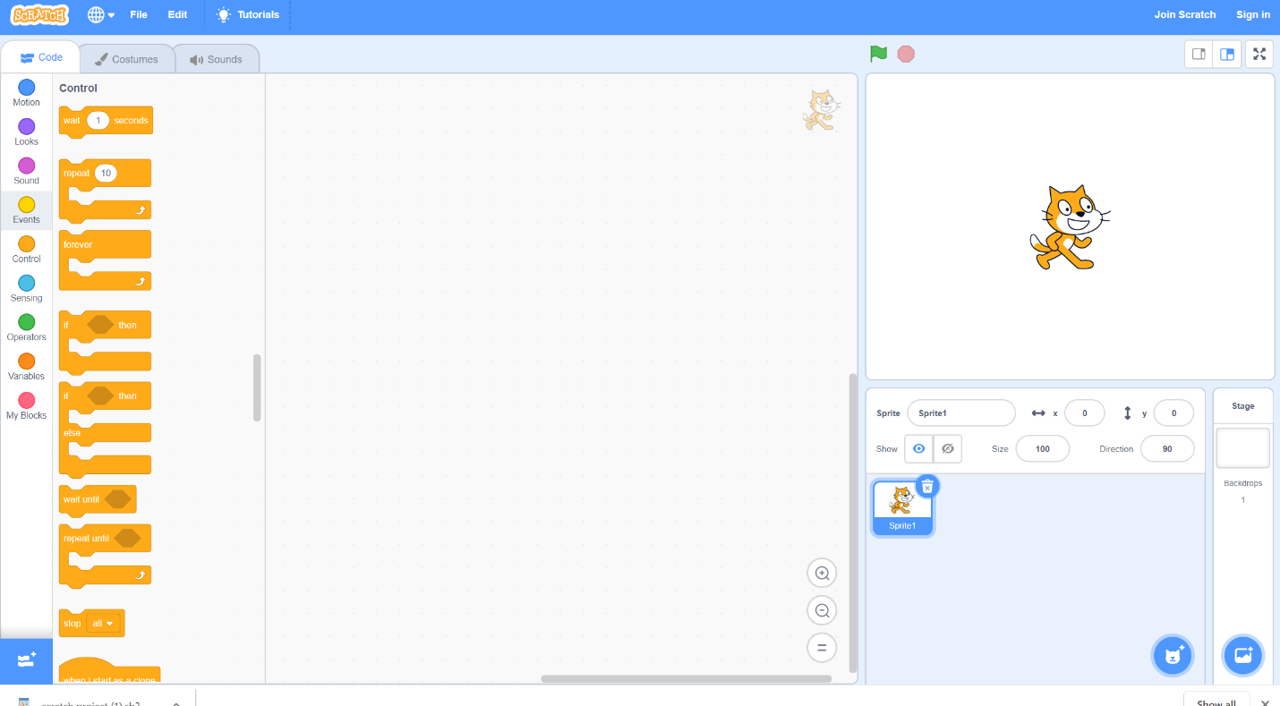

**Sensing blocks are the blocks that detect things.**

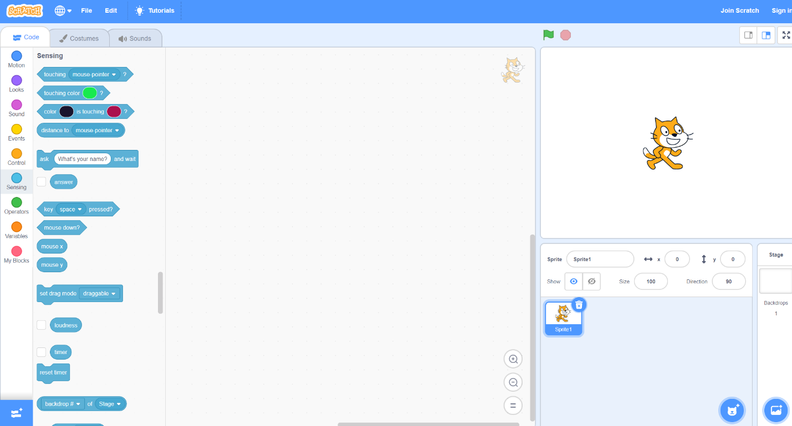

**Operators blocks are the blocks that perform math functions and string handling.**

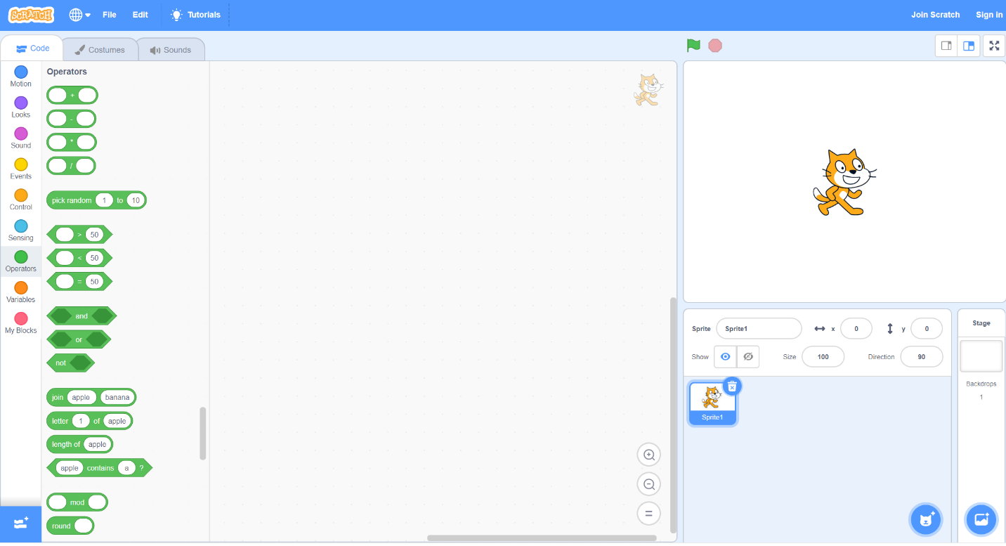

**Variables blocks are the blocks that hold variables and lists.**

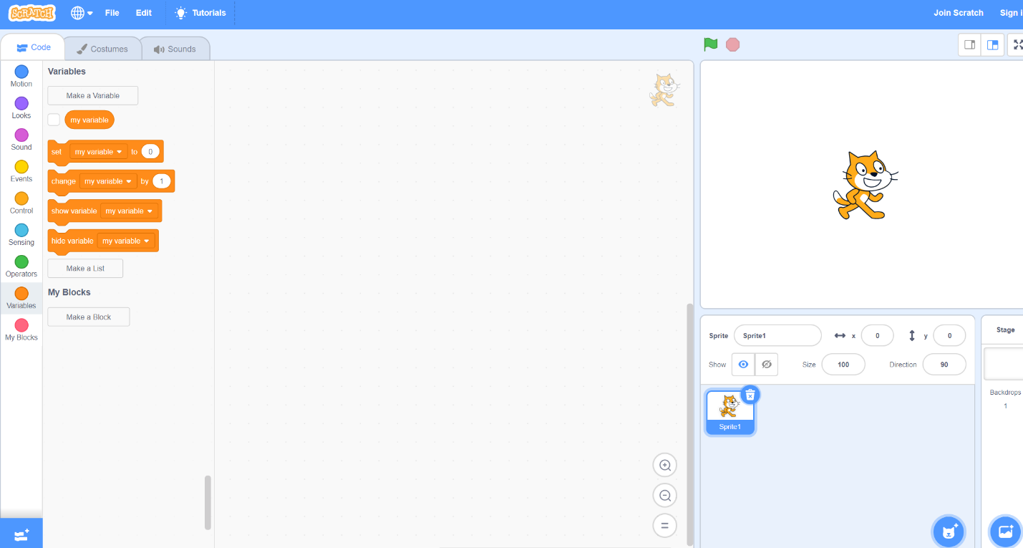

**My blocks are user made custom blocks.**

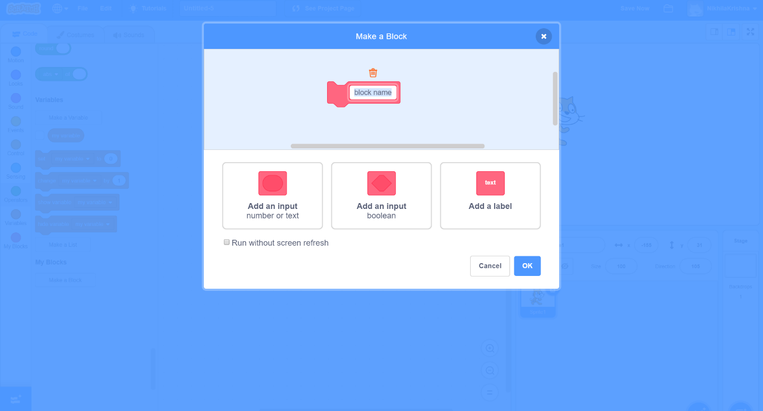

**Globe icon explains which language we have to choose to write the code.**

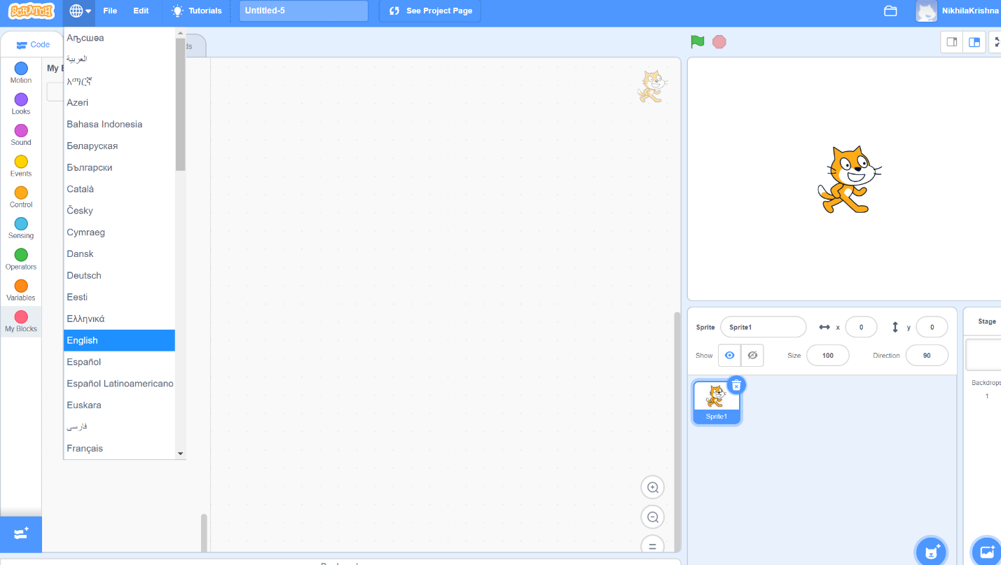

**File contains few options which consists of new, save now, save as a copy, load from your computer, save to your computer.**

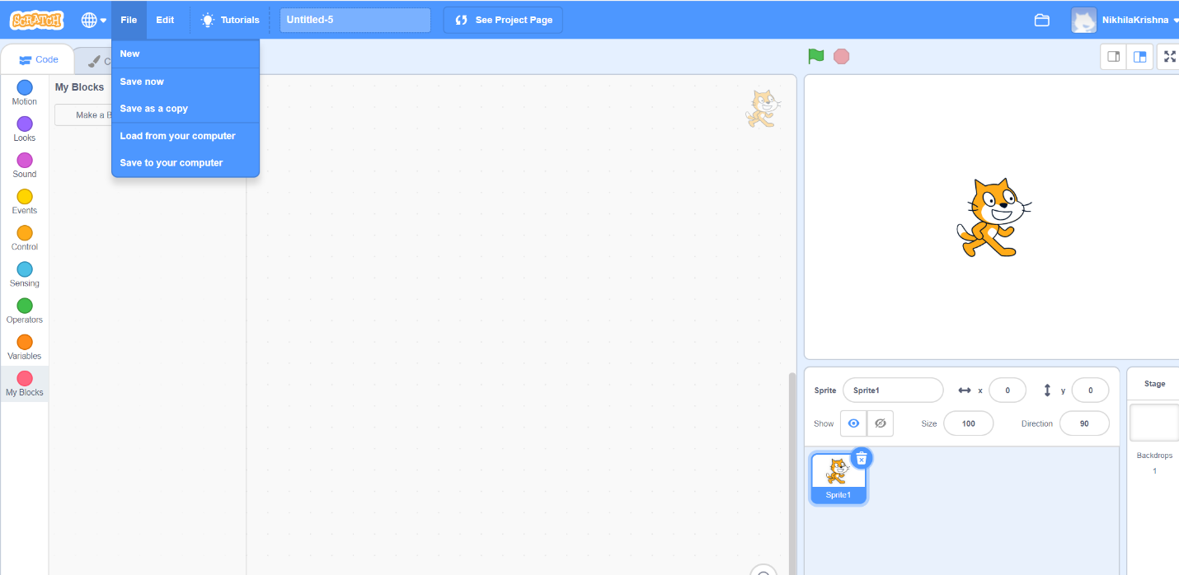

**Edit icon has only two options which explains about restore and turn on turbo mode.**

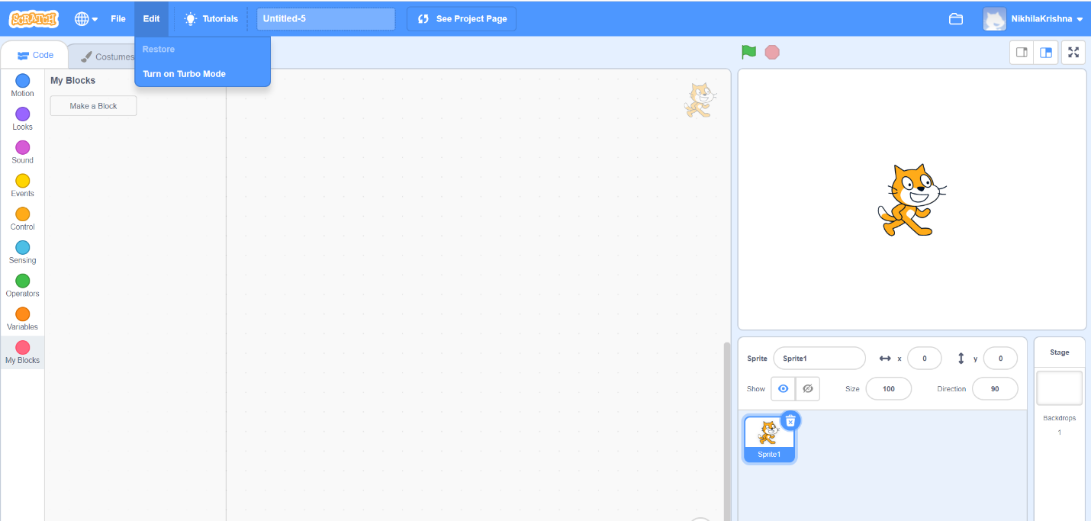

**Here we can view the saved projects in our webpage.**

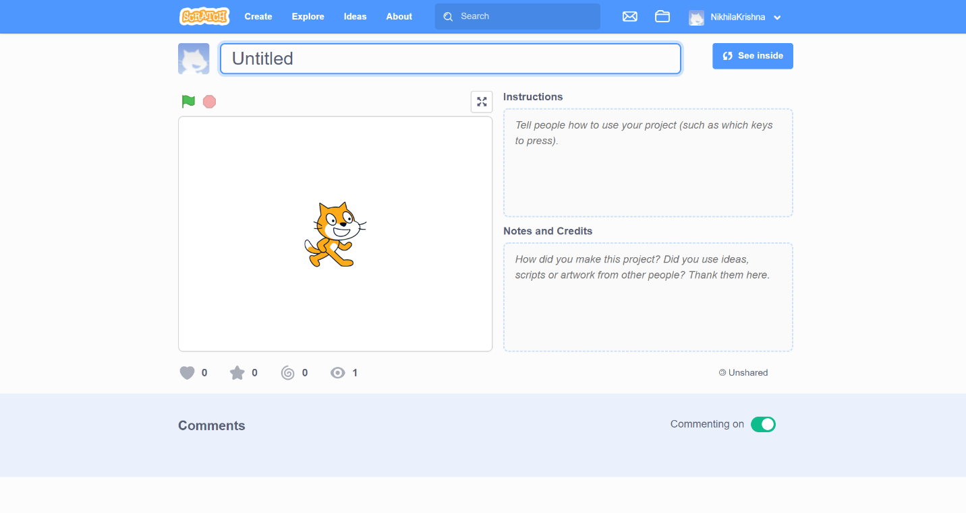

**This is the page where we can choose a sprite images.**

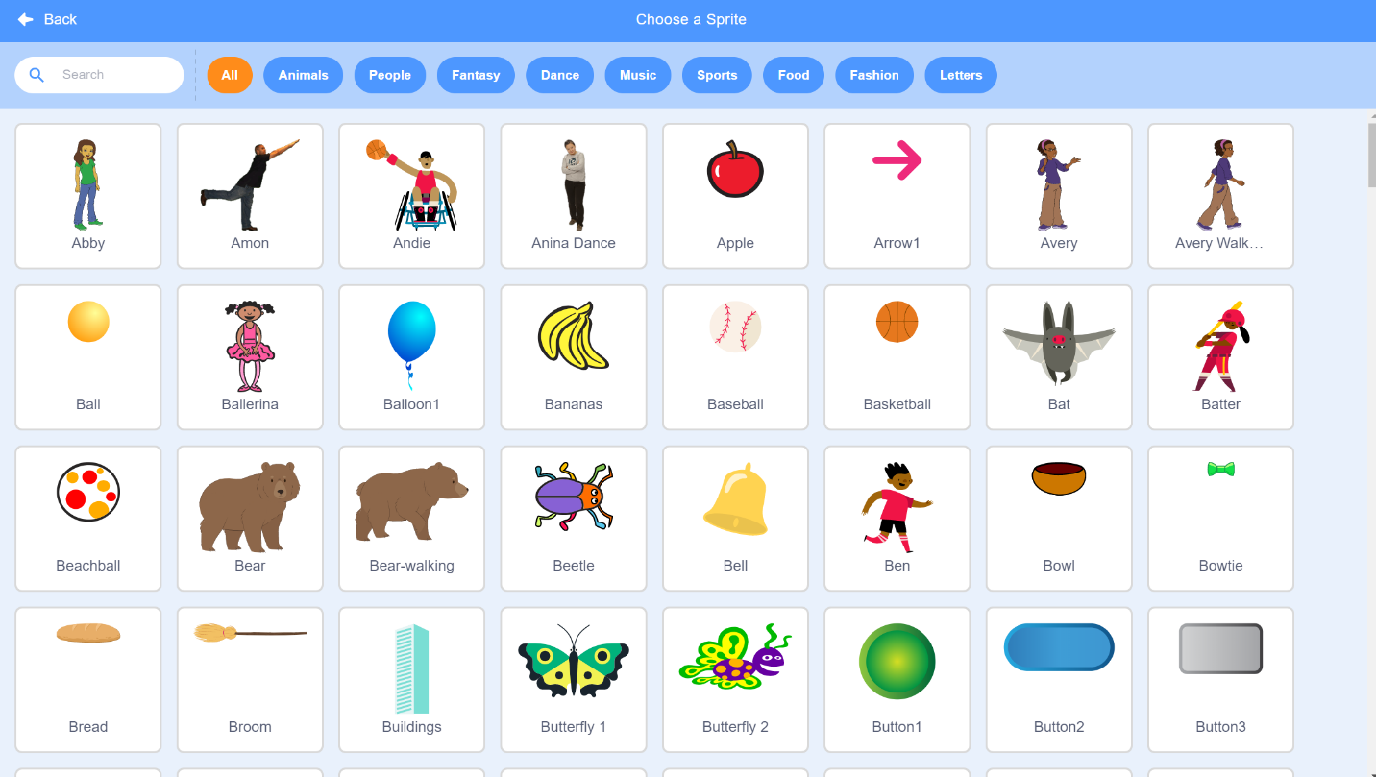

**Here we can choose a backdrop for the project.**

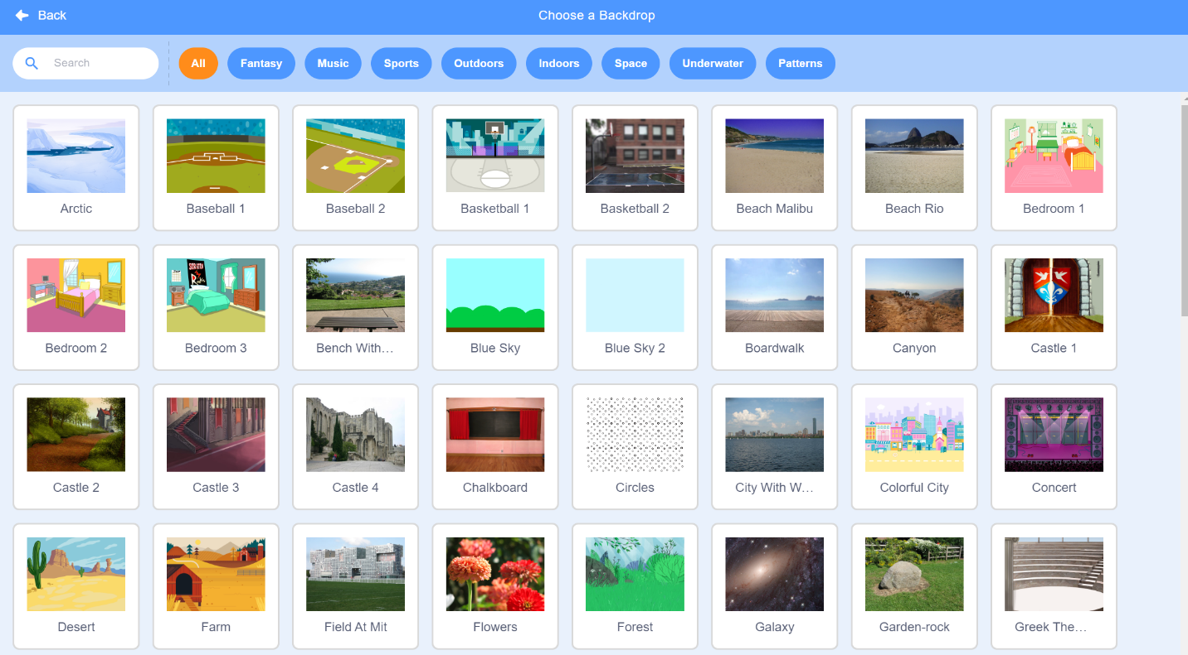

**This is the sounds page where we can cerate a backdrop sound.**

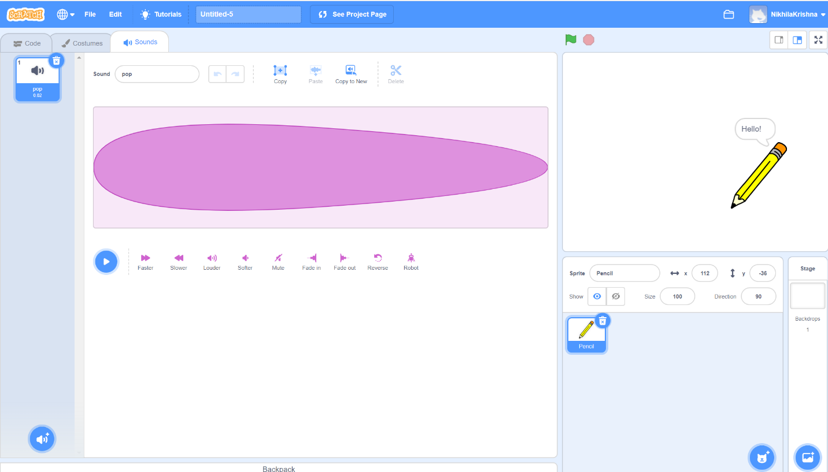

**This is the costume page which has the image of the sprite.**

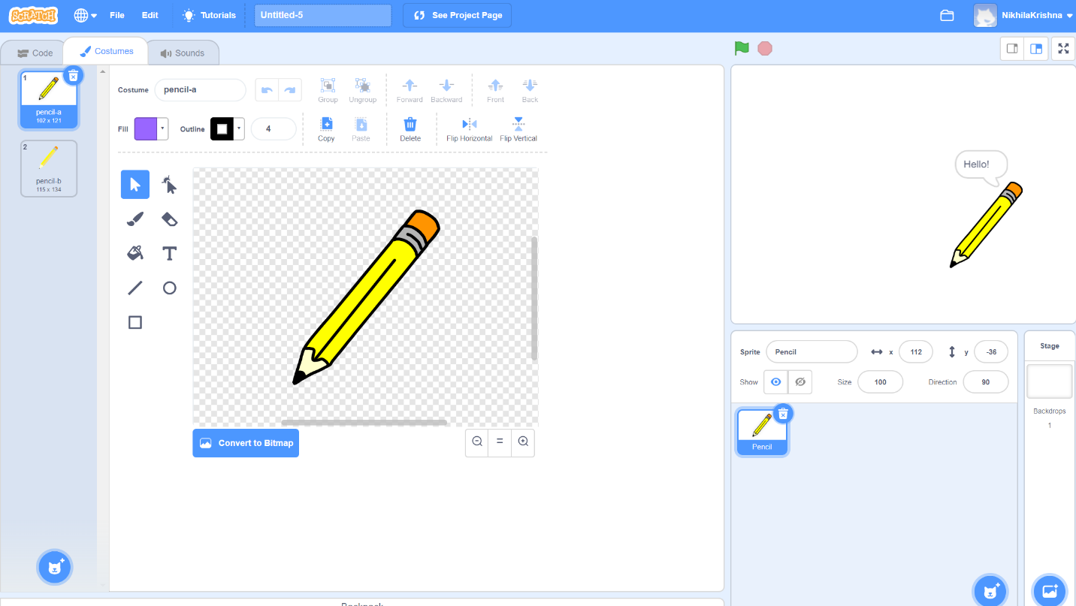

**PICTURES OF OUTPUT**

**Here I choose the offline editor scratch 2.0 for developing the project code.**

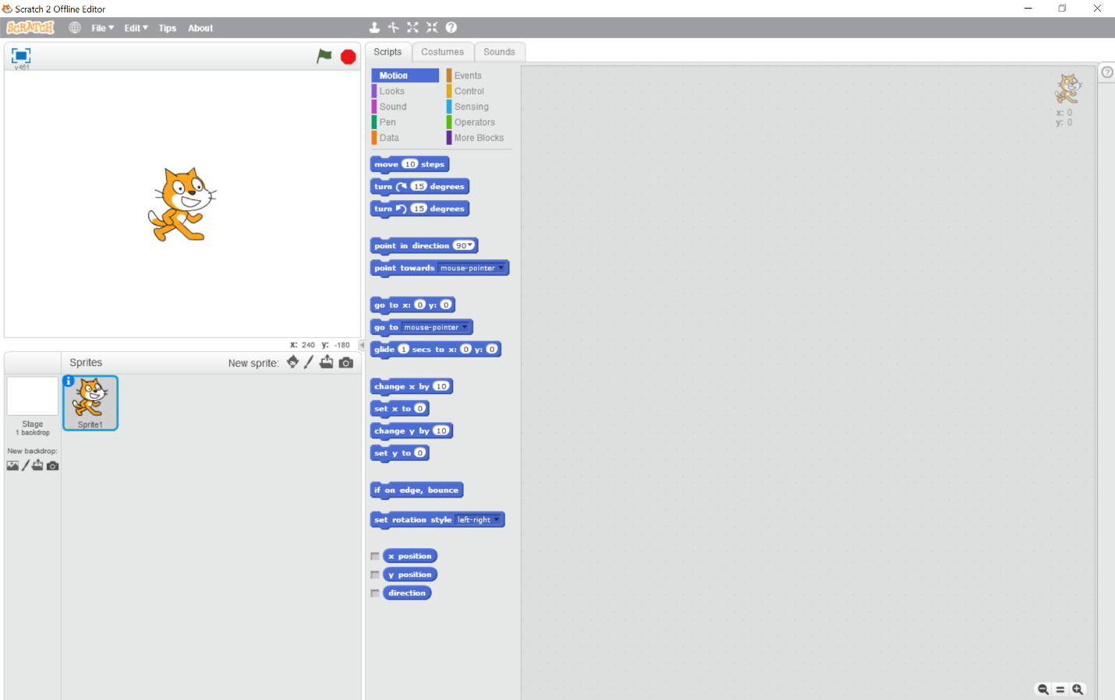

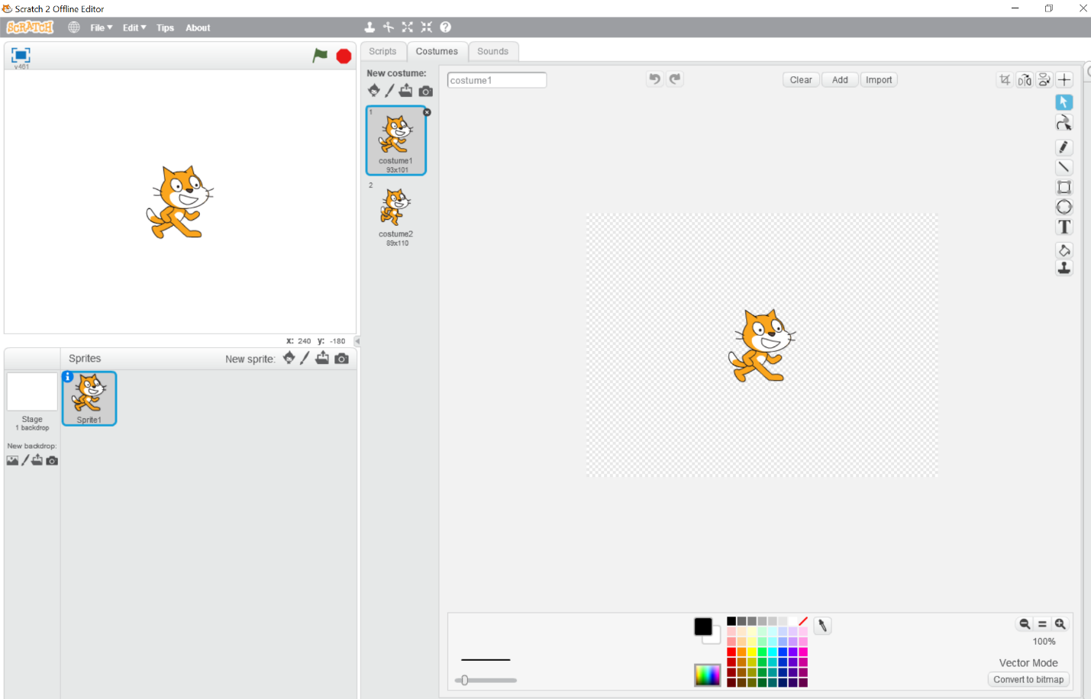

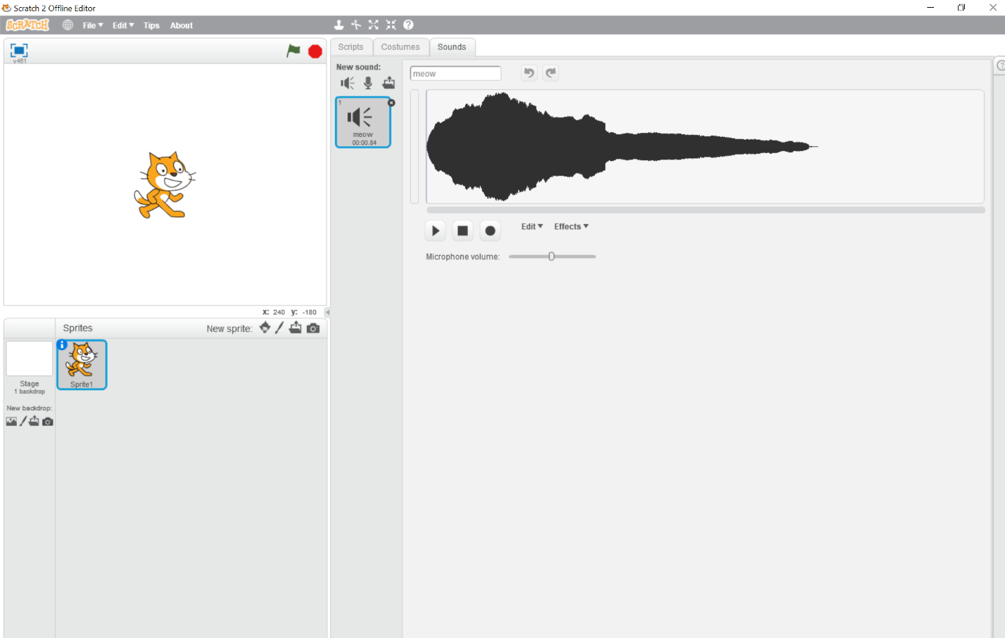

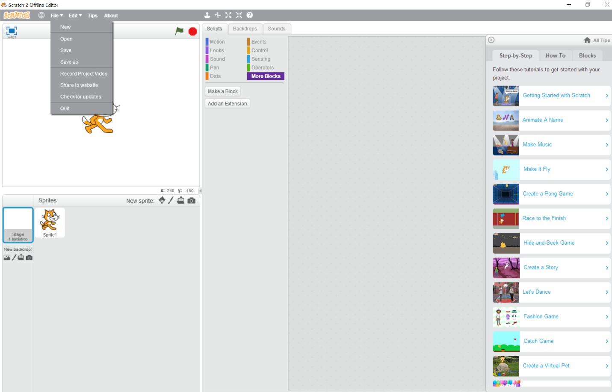

**These are the output screenshots of the project.**

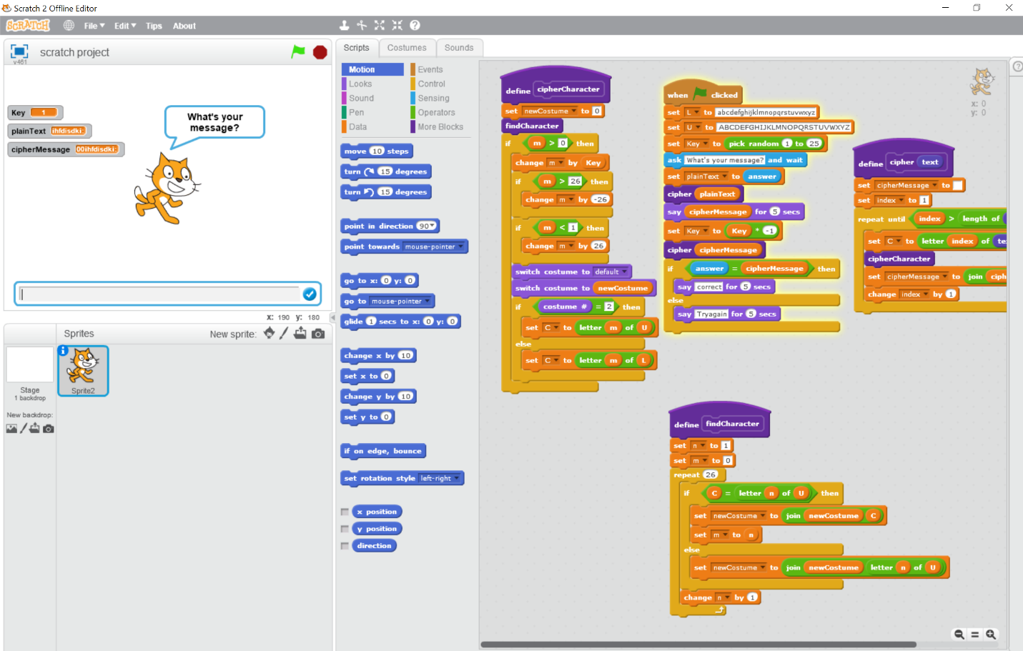

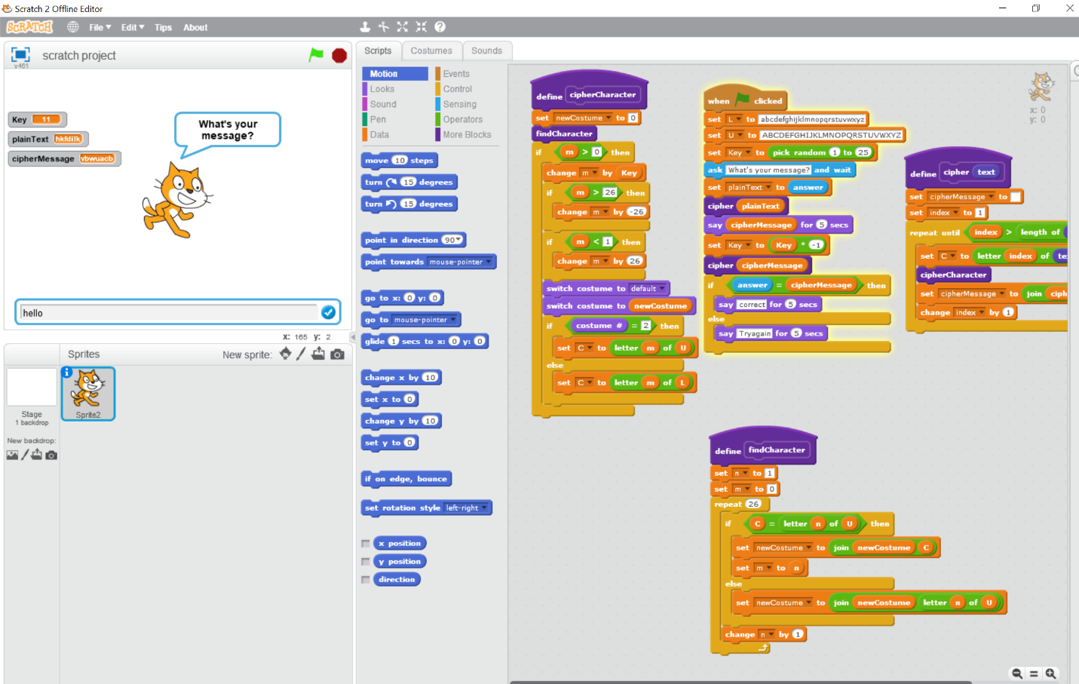

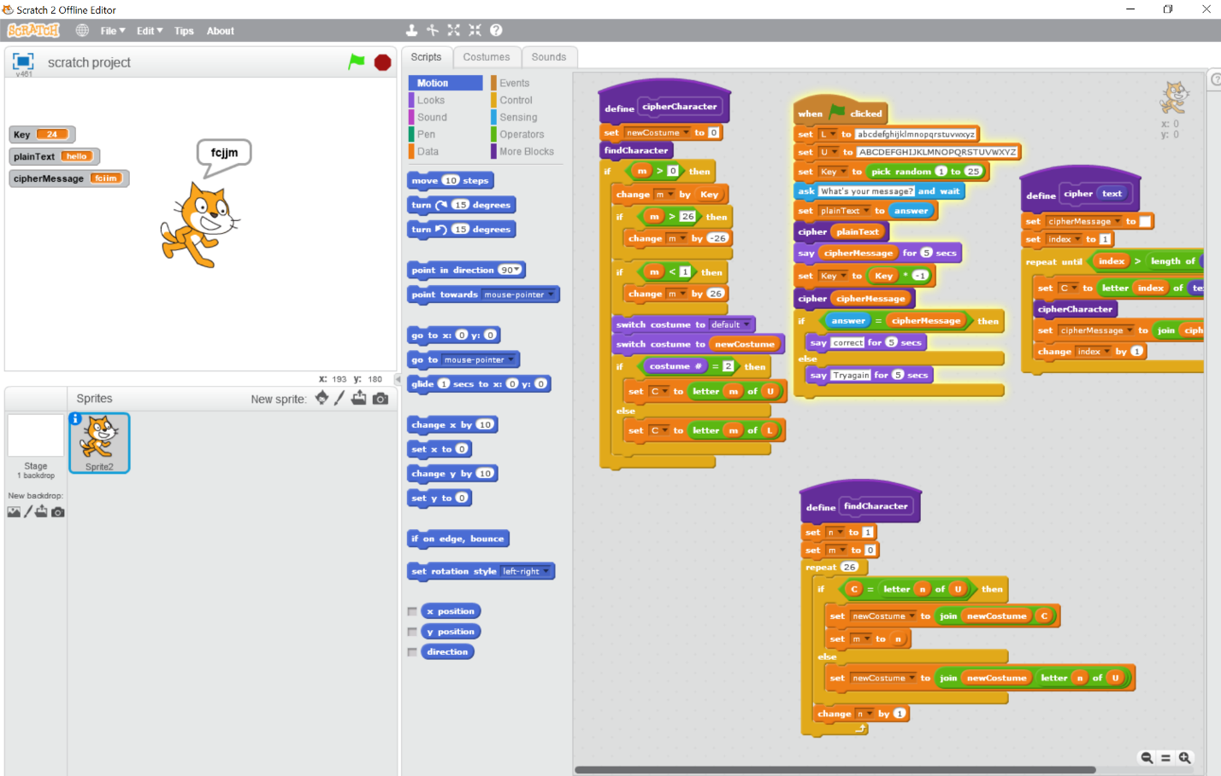

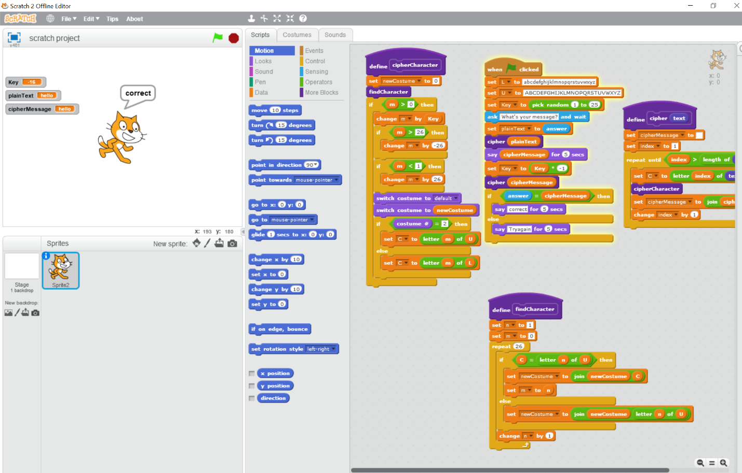

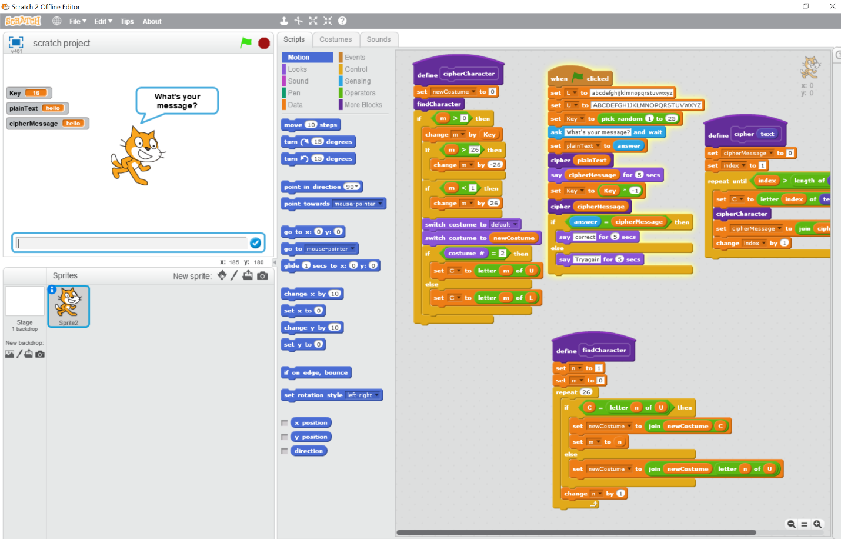

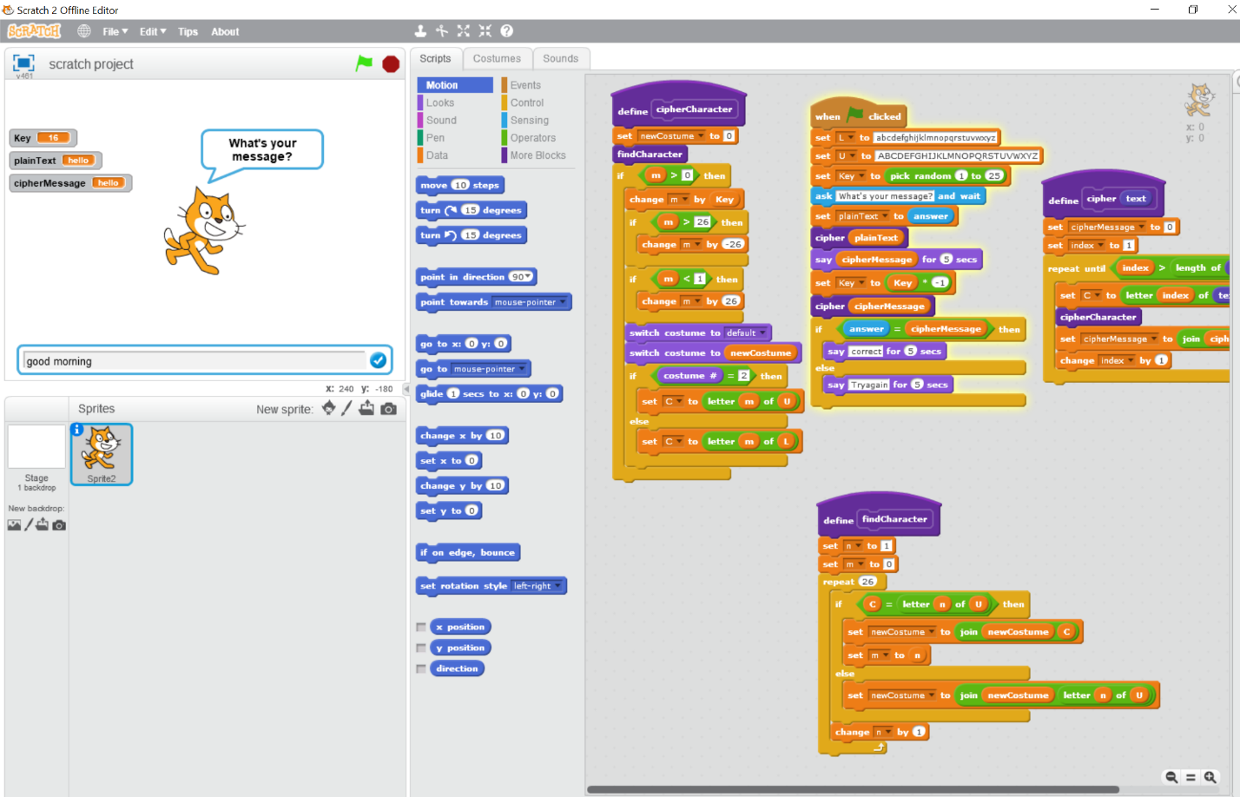

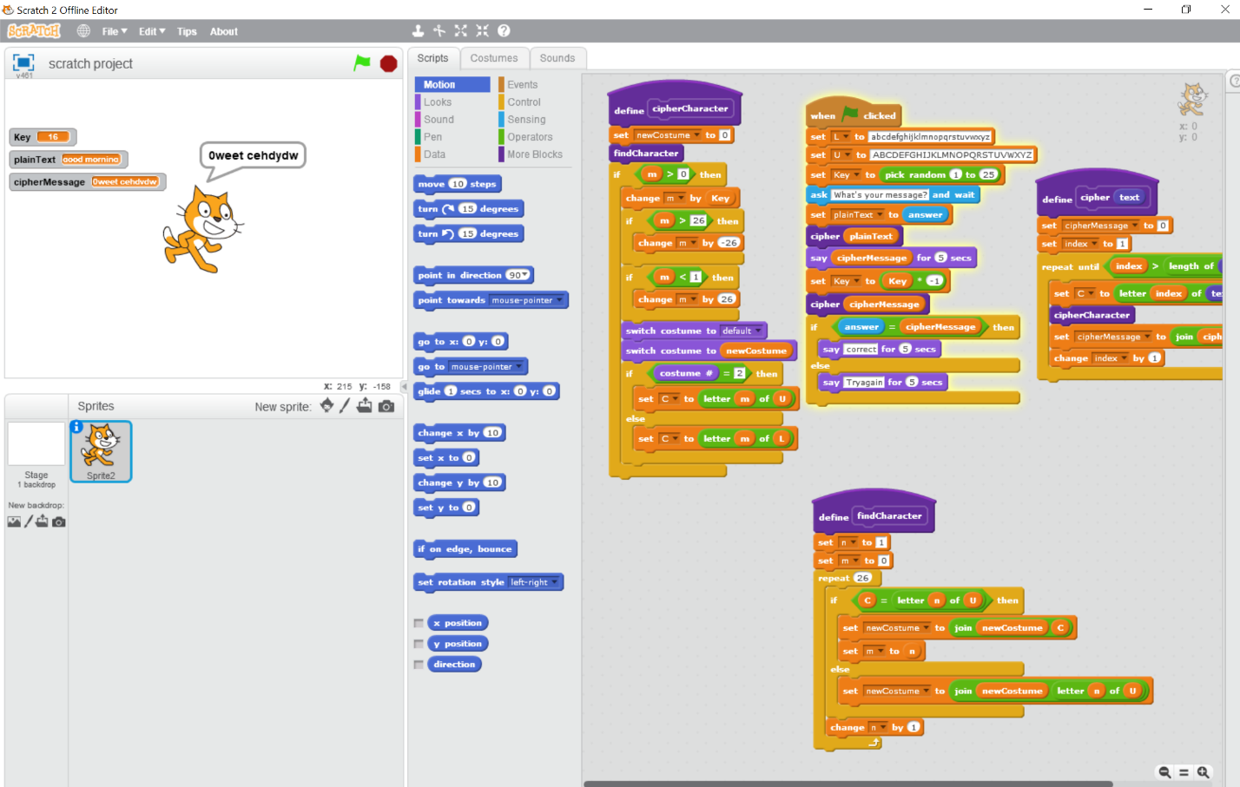

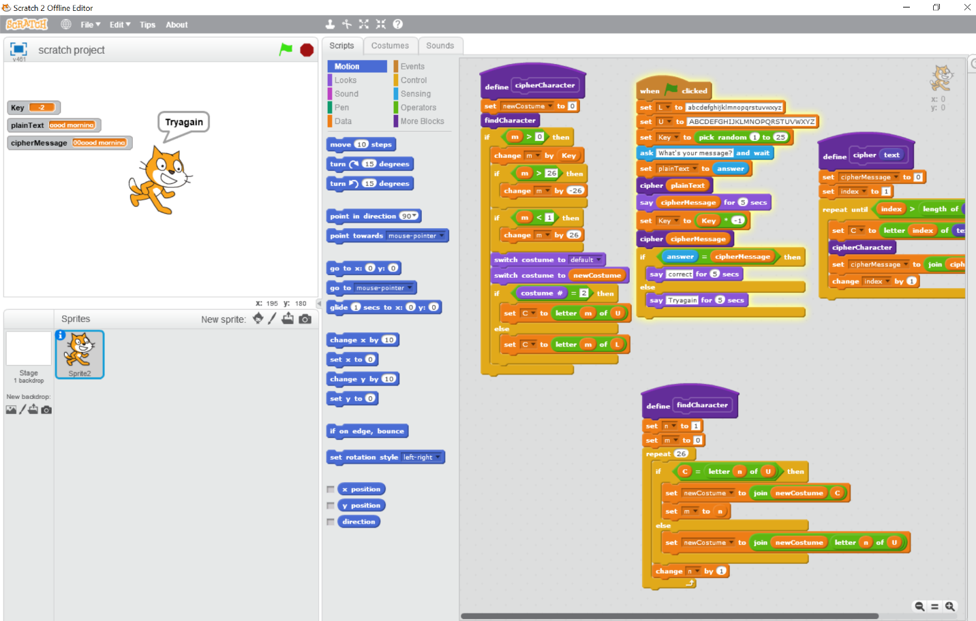

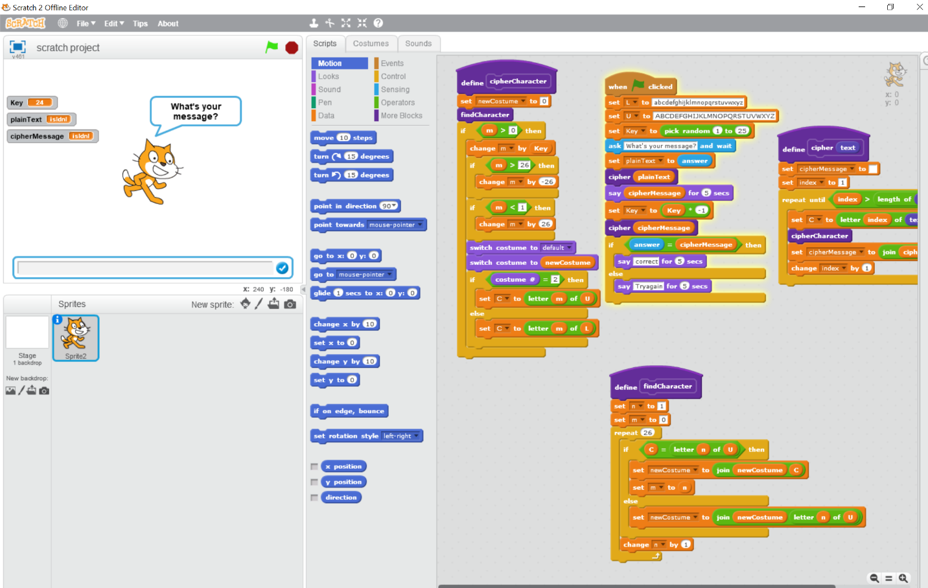

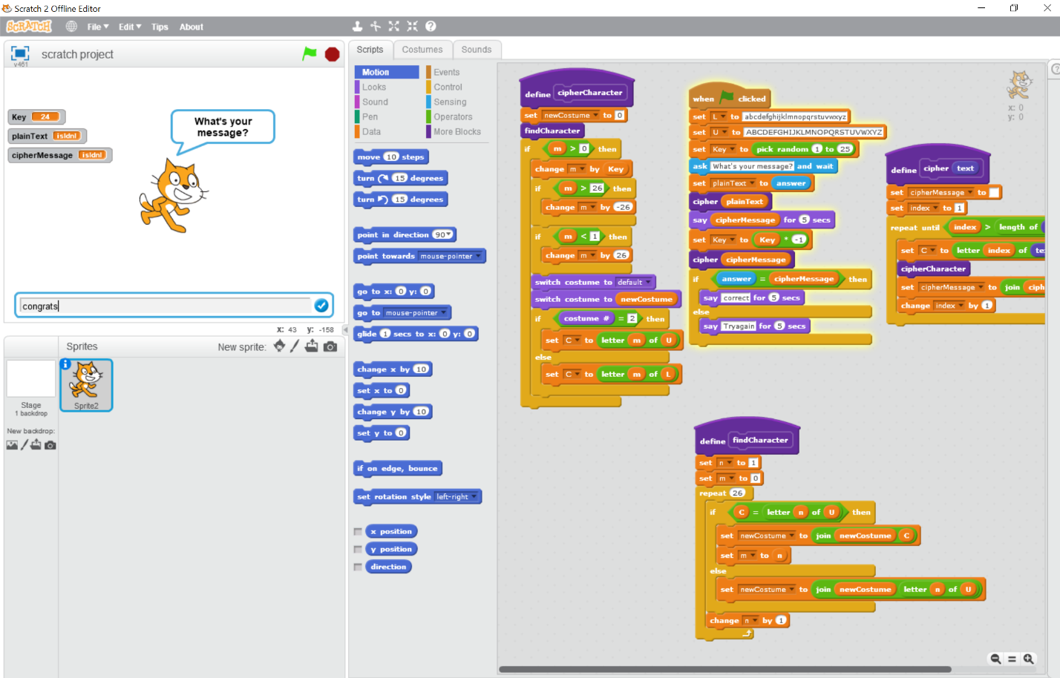

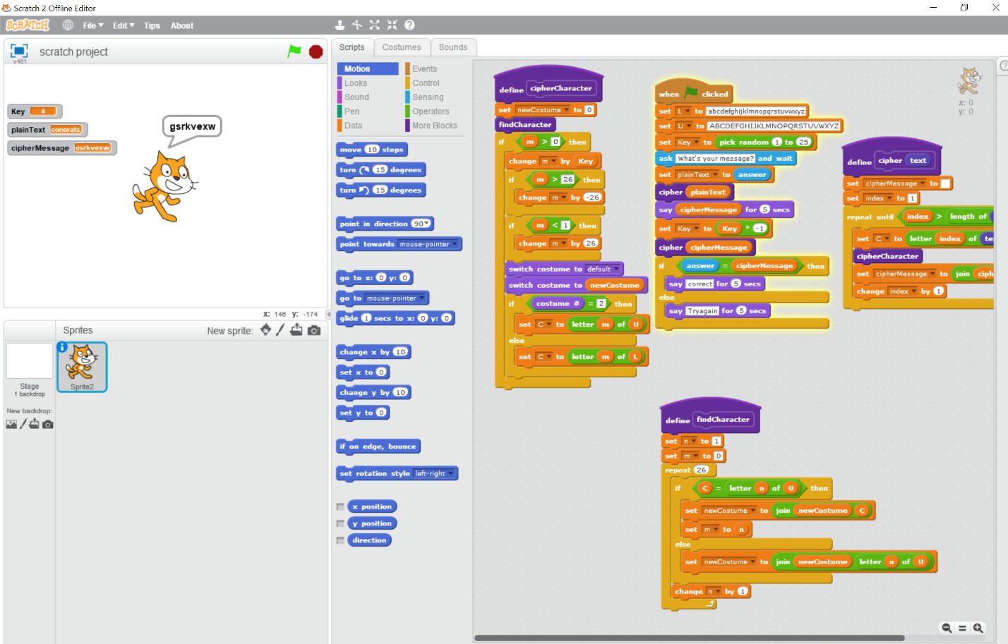

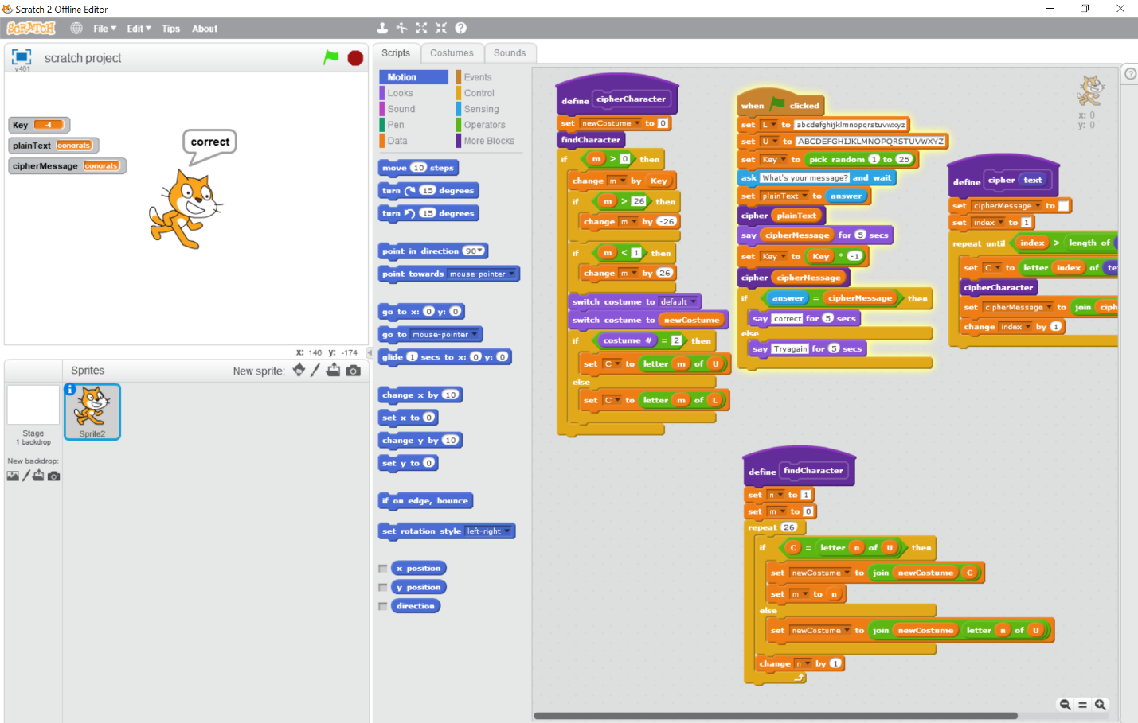

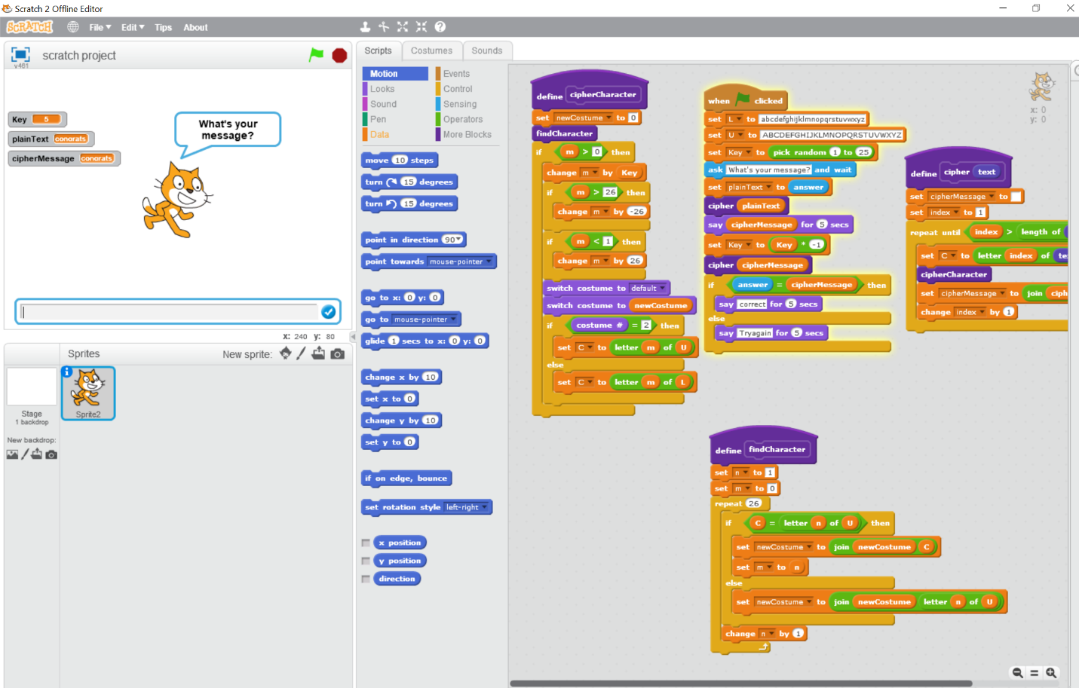

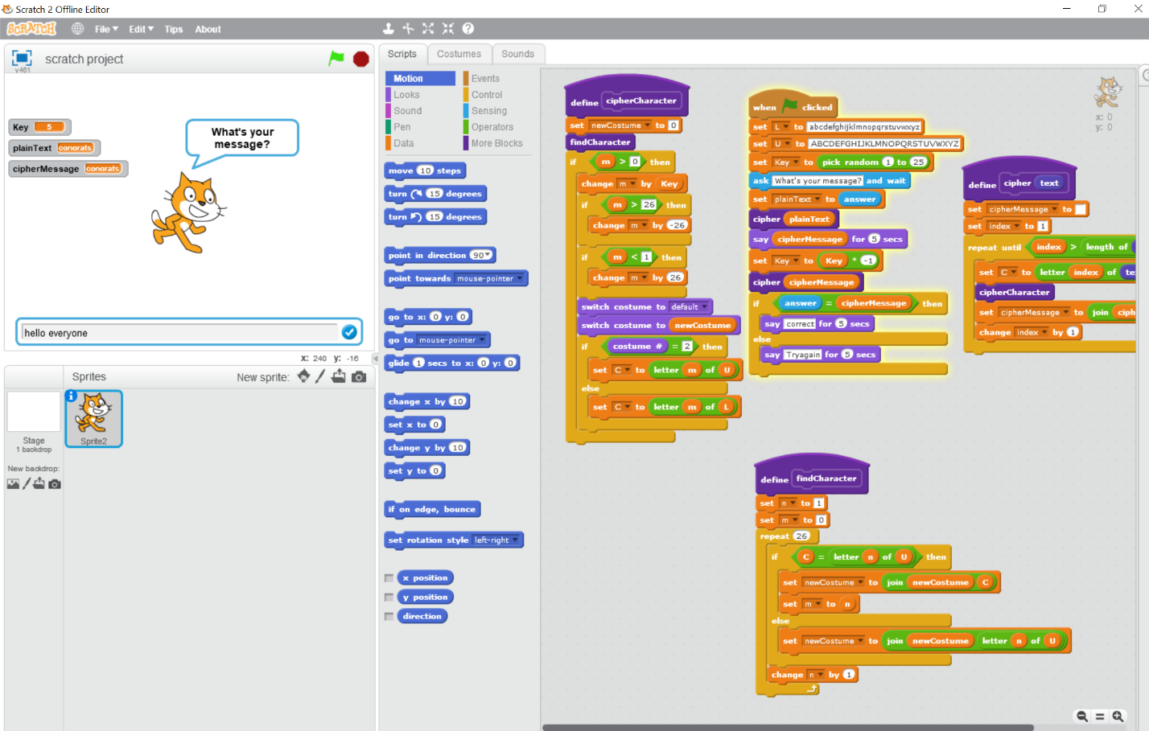

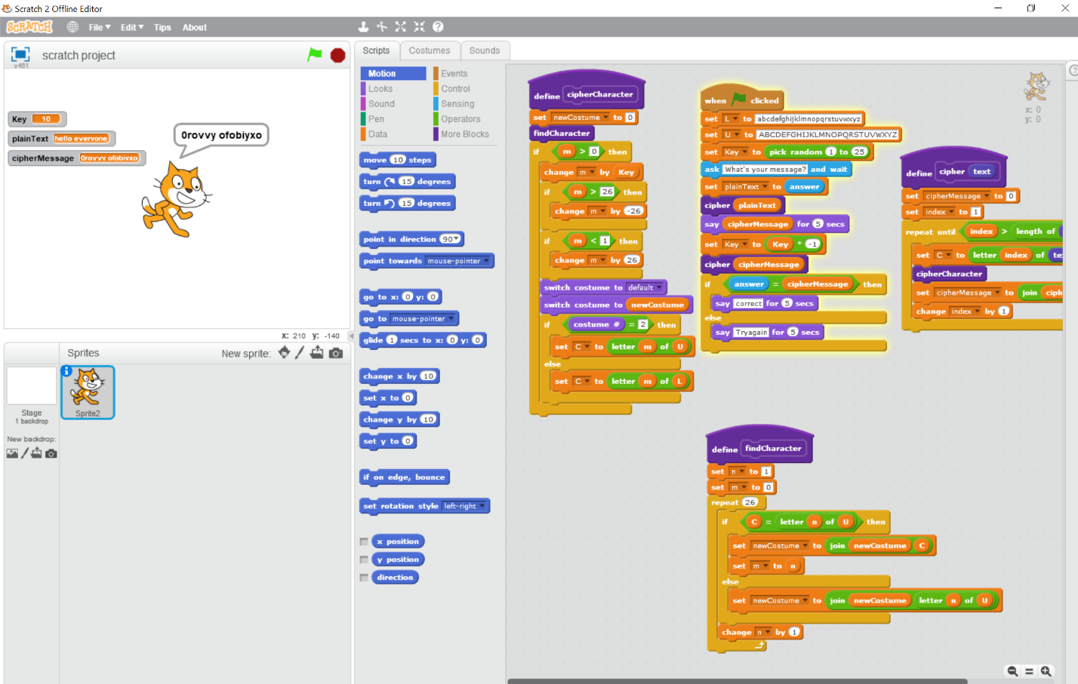

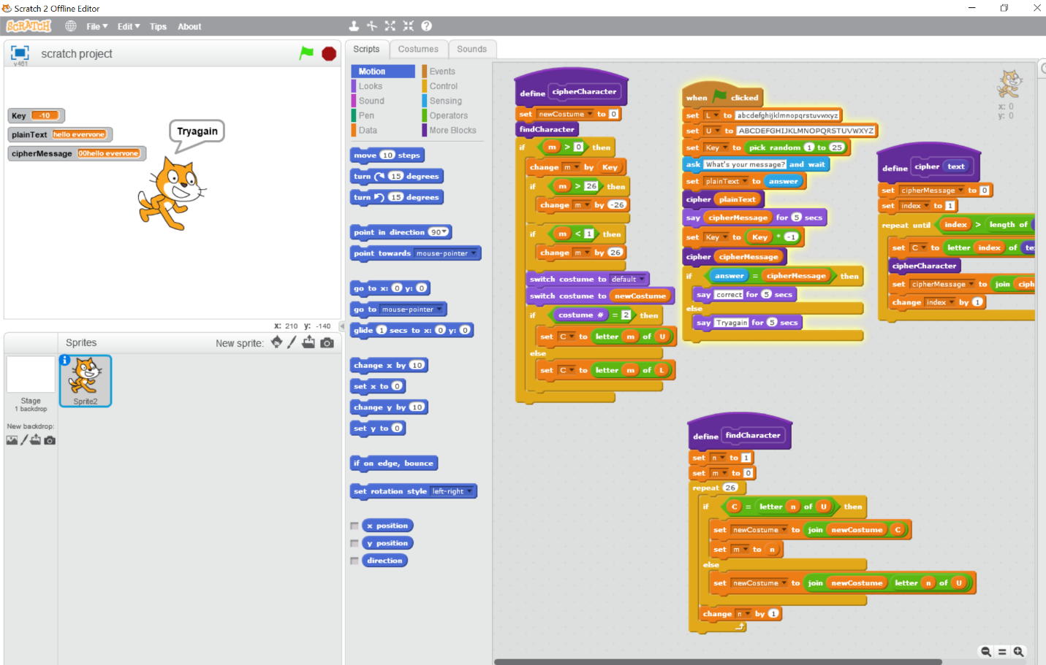

**CONCLUSION**

I think this is the simple webpage to develop the projects for students. Here in this webpage creation i think the offline editor gives you better impact of the development rather than the online version. Here I created both the offline editor and the online page. What I observe by developing this webpage is offline can be saved easily and the online version is saved by using the file name save from your computer. By using this we can upload the required file from the saved file. After that we can again have to save it into the project file. We can open it any time and we can run the project version. We can upload it from the offline version also. Offline version is the safest version without any backdrops of the required webpage. Online editor upgrades some minor errors in making the project. This is one of the easiest webpage to develop a project for students to learn the concepts in an easy way. This is a block-based programming language irrespective of the other programming languages like java, c++, python etc. we can develop the project by using app in our mobile but I choose to develop a webpage useful for the children and it is easy to create a webpage based informative game rather than a application based game. In this block-based programming language we can develop our own blocks respective to our vision. As of our criteria we can add up our own blocks. In this programming language there is no particular pattern to create a code, as our wish we can develop our blocks in this webpage. We can add our own backgrounds, sounds, required for our project. We can addon some sounds when we create for kindergarten students and for the preprimary children. This code which I have developed can be written in several other ways by using many other different blocks using different loops and tags. Here we can add the tags like the variable names for each specific lines of the code which we have written in this webpage creation.

**CODE**

As it is a block-based programming language, It is unable to copy the blocks. So, I mention the screen shots of this block code.

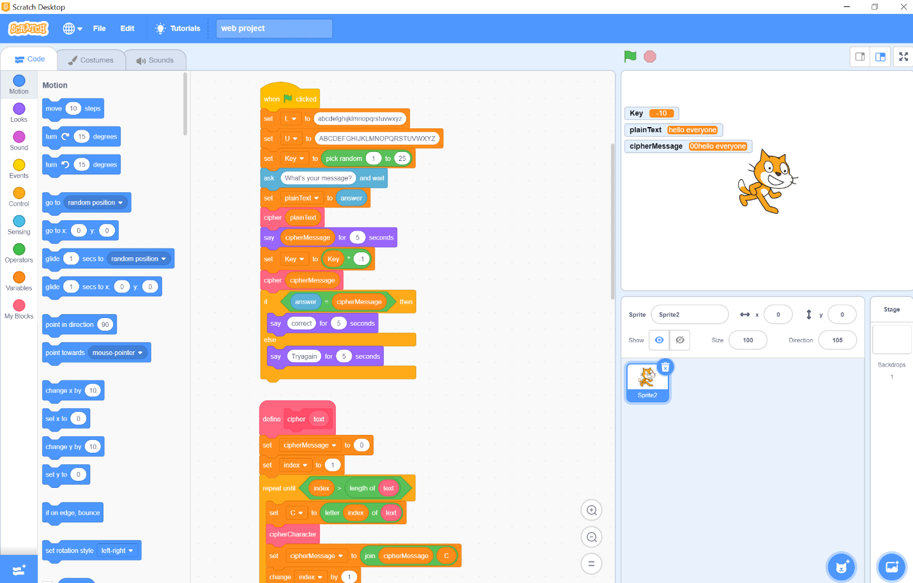

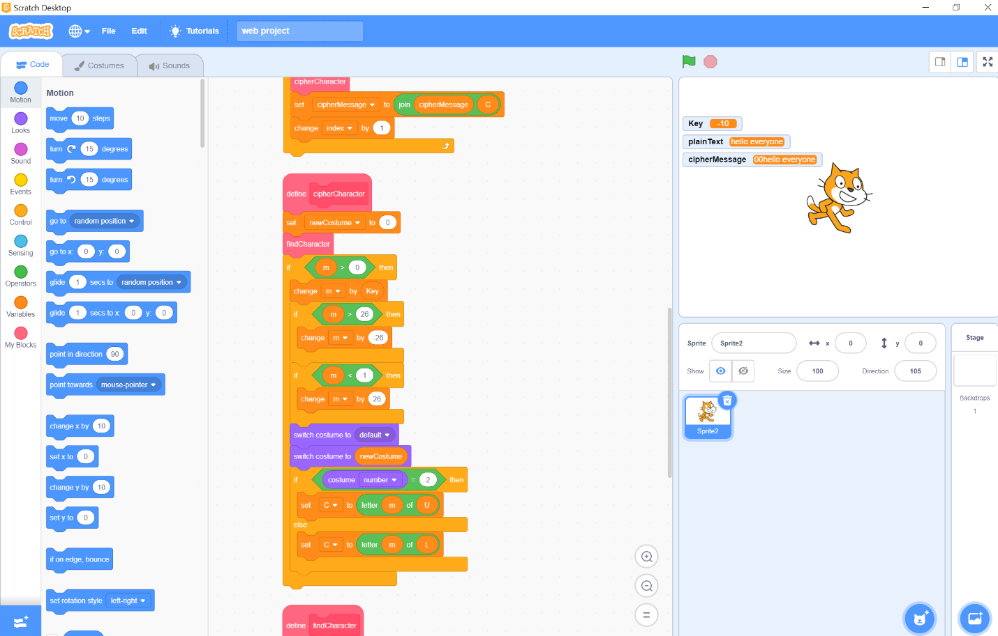

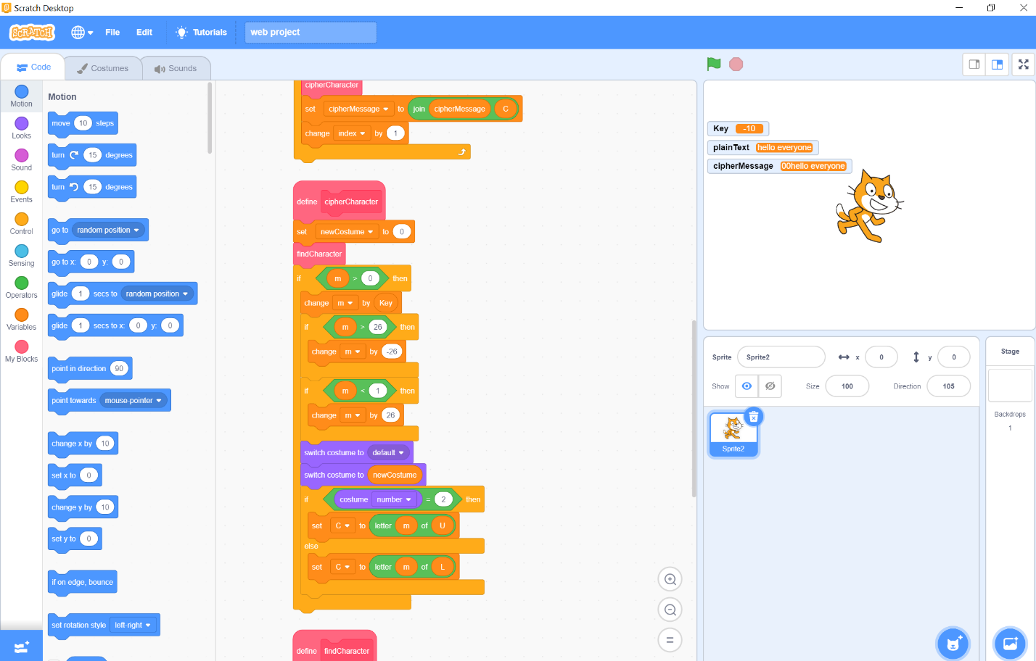

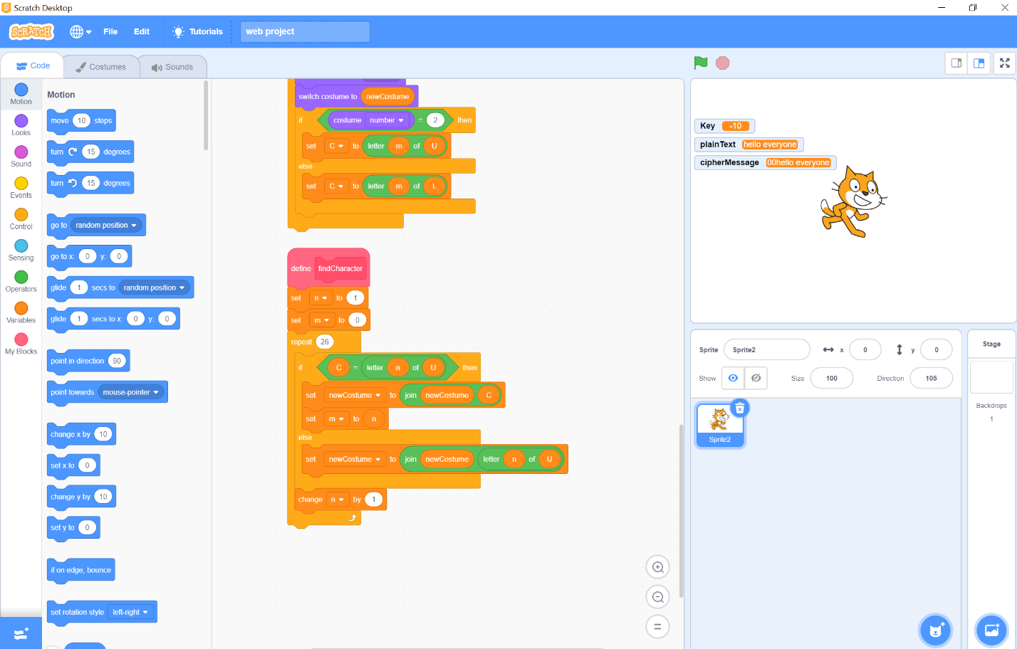

**ZIPPED DIRECTORY OF MY PROJECT**



**INSTRUCTIONS OF UNZIPPING AND RUNNING THE PROJECT**

1. After double clicking on the scratch project.zip will get a tab like this,

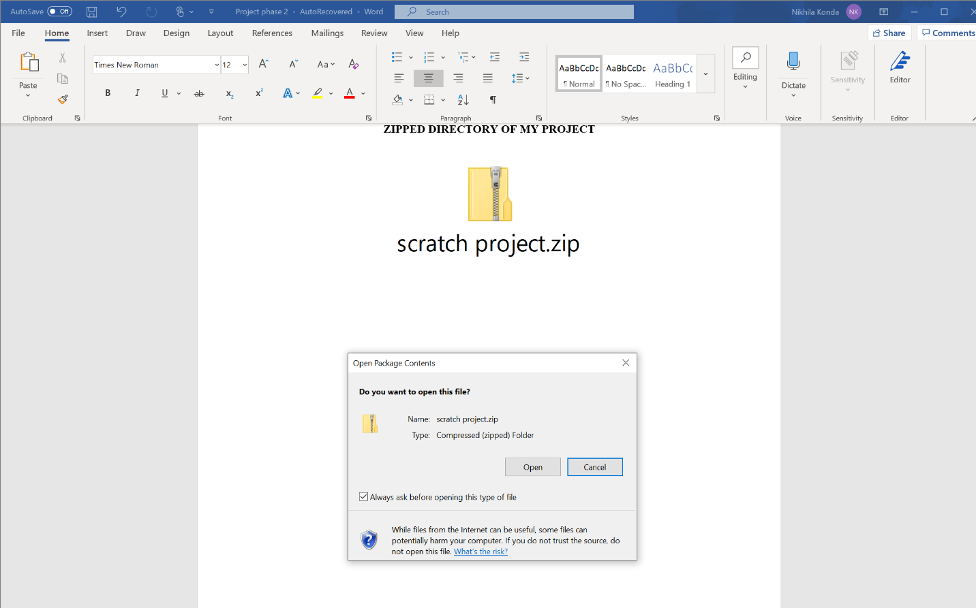

1. Then click open, you will get a screen like this

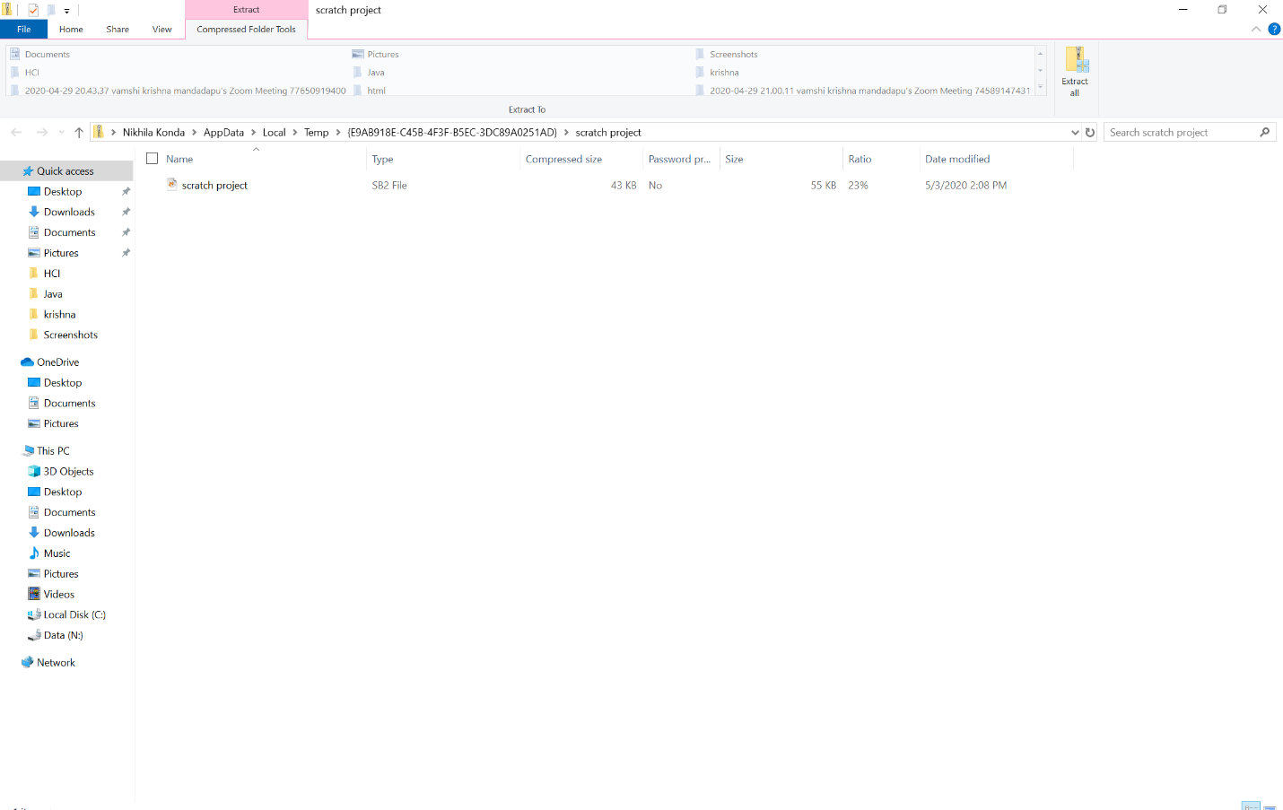

1. Then click of the scratch project file , you can open the project directly.

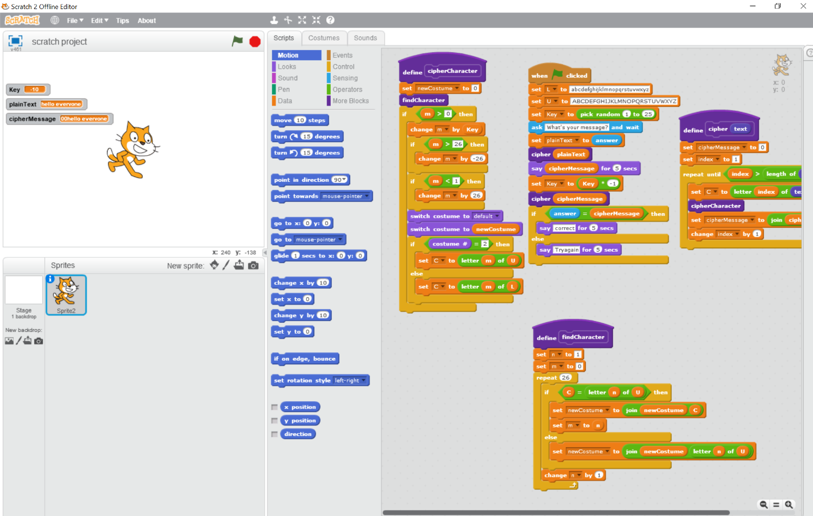

1. After opening the project, you click on the green flag to run the project.
2. You have to type any text on the empty block or space and click enter. You will get the encrypted data regarding that. If it is correct it will show it is correct and if it is wrong it will display try again on the screen.